Ideation Phase
Define the Problem Statements

Date | 31 January 2026
Team ID | LTVIP2026TMIDS24962
Project Name | Empowering India: analysing the evolution of union budget allocations for sustainable growth
Maximum Marks | 2 Marks

Customer Problem Statement Template:
This project helps business stakeholders, startups, and industry analysts explore Union Budget allocation data (2021–2024) related to ministry-wise, category-wise, and scheme-wise funding. Using SQL and Tableau, the project visualizes revenue and capital expenditure trends to guide strategic investment decisions in Renewable Energy, Electric Vehicle (EV), and pharmaceutical sectors.
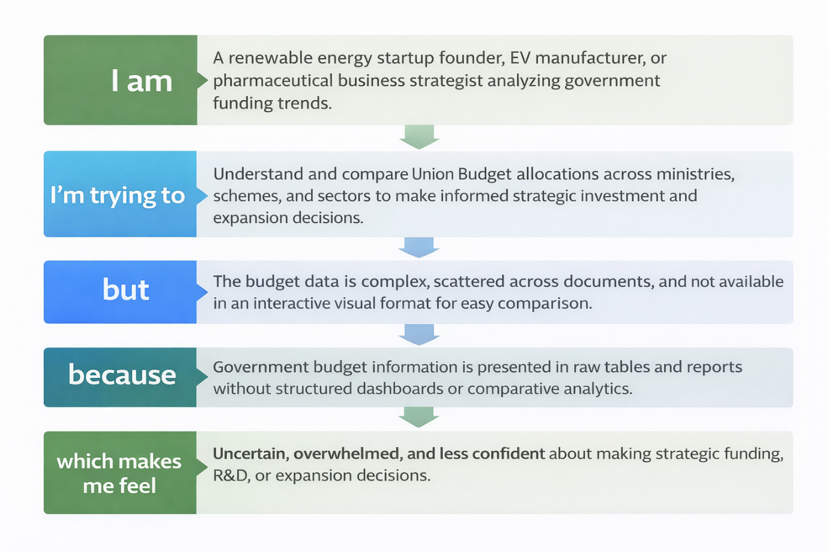
Reference: https://miro.com/templates/customer-problem-statement/

Example:

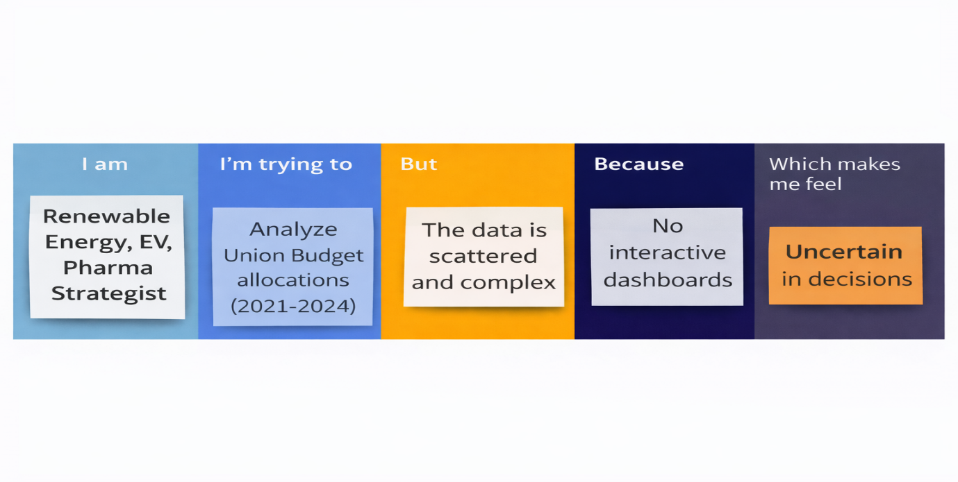
Problem Statement (PS) | I am (Customer) | I’m trying to | But | Because | Which makes me feel
PS-1 | Renewable Energy, EV, or Pharmaceutical business strategist analyzing government funding trends | Understand and compare Union Budget allocations across ministries, schemes, and sectors. | Budget allocation data is complex and scattered across various reports and documents. | There are no interactive visual dashboards to easily view and compare the budget data. | Uncertain and overwhelmed about making strategic funding, R&D, or expansion decisions.
PS-2 | A renewable energy startup founder | Track government investments and support in renewable energy initiatives. | Year-wise funding trends for renewable projects are not visualized | Revenue and capital expenditure data are not clearly separated | Unsure about strategic R&D and expansion planning.

